**Is Angelina Jolie a Whacko?**



Angelina Jolie needs no introduction to millions of fans across the globe that have followed her career on and off the big screen. She is a film maker and a humanitarian activist apart from being a celebrated actress. So much has been written about Angelina Jolie but not much has been said about the tumults she generates in personal life as she advances towards the middle age.

She was born in Los Angeles, California on June 4 1975 as Angelina Jolie Voight to a prominent family in Hollywood. Her father, Jon Voight is a famous American actor who has won several awards including an Academy award and four Golden Globe awards.

It is hard to pinpoint which film Angelina is best known for, because almost all films she has starred in have been blockbusters, the most commercially successful one being the dark fantasy film *Maleficent* (2014), which grossed over $758 million across the globe. She has been cited on several occasions as the highest paid actress in Hollywood.



For her brilliant performances, she has been decorated with Academy Award, two Screen Actors Guild Awards, and three Golden Globe Awards. She first appeared on the big screen in 1982 alongside her father in *Lookin' to Get,* but her first big starring role was in *Hackers* (1995).

Her Academy award was for the Best Supporting Actress in *Interrupted* (1999) and thereafter there was no stopping her as she appeared in one action-film or the other every year up to 2016. In 2016, she lent her voice to *Kung Fu Panda.* In 2017, she directed the film *First They Killed My Father* (2017) and was the Executive producer of *The Breadwinner.*

However, it is the drama playing out in her real life that is attracting considerable attention of many onlookers. First from an early age, she was marked out as the ‘wild child’ in Hollywood for her playing with knives, dabbling in drugs, bisexuality and sadomasochism. She admits using knives in sexual foreplay and doing any drug imaginable.



Angelina has been married three times. Her first marriage was in 1996 with her co-star in Hackers, Jonny Lee Miller. Not surprising, the marriage lasted only 3 years. During the wedding, she appeared in a wedding attire that included a white T-shirt with the name of her bridegroom written in blood.

She is prepared to do nude scenes or kiss and make love to other women even though she claims she is not gay. She has tattoos written on her body with one that reads “Quod me nutrit me destruit” which is the latin expression for “what nourishes me also destroys me."  She once wanted to go to a premiere with the Hell’s Angels but of course, failed to do that.

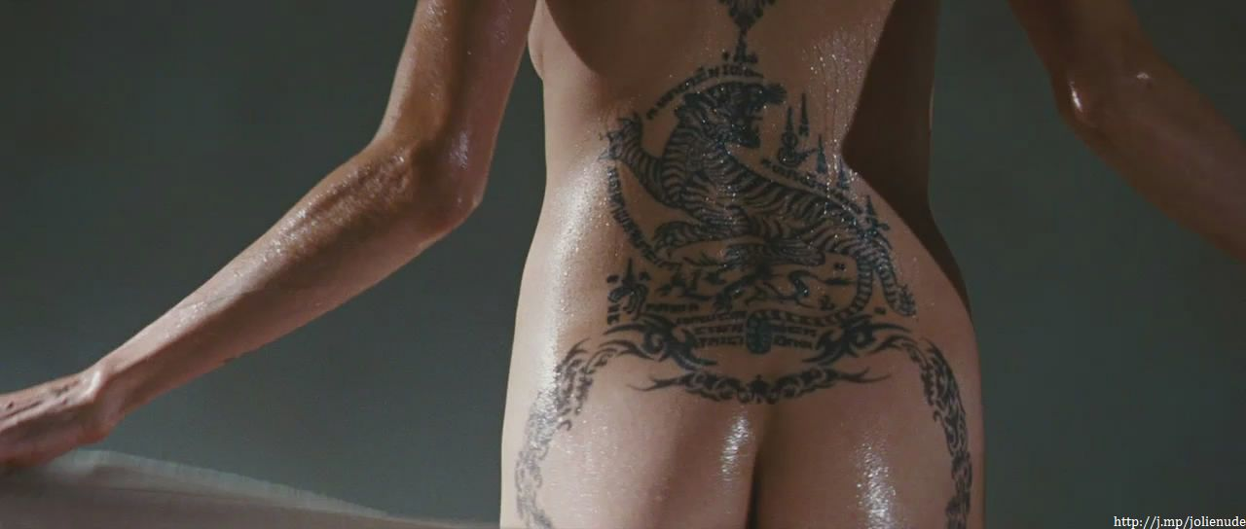

Angelina married the actor Billy Bob Thornton in 2000 and during the marriage which also lasted only 3 years she would appear in public with him wearing vials covered in his blood around her neck. She is married, for the third time. This time to another famous actor Brad Pitt whom she married in 2014 but by 2016 they were already separated even though they adopted 6 kids together. She is currently suing for a divorce.

She kissed Jams Haven, her brother, publicly after receiving an Oscar award sparking rumours that she indulges in incest. She has also been photographed in scenes that suggest she practices bestiality.



Angelina believes she is just trying to be expressive and be herself. The average person may think she is a whacko.